APA Style

1. Basic Rules:
   1. 12 point font
   2. Times New Roman
   3. 1 Inch margins
   4. **Double spaced**
2. The physical page:
   1. Centered Results on the first line
   2. No double double space (i.e. don’t hit enter twice)
   3. 2 or 3 decimal places (be consistent)
   4. Statistical abbreviations are *italicized (t F p M SD SE)*
3. The order
   1. Explain variables first, give people a brief warning about what’s going on
   2. Start with Descriptives
      1. Mean *M*
      2. Standard Deviation = *SD*
      3. Standard Error = *SE*
      4. Most common thing to list is the Mean and Standard Deviation
      5. For each group or variable or those combinations.
      6. If there are a lot of variables, you can make a table or chart
      7. Usually depends on the data…
      8. Do not spell out numbers (sometimes you’ll spell out ones less than 10, but that’s pretty inconsistently applied).
      9. Do not abbreviate variable names (aka it needs to be in English!).
   3. List the test that you performed (ANOVA, t-test, etc.).
      1. Tell if the test was significant or not, but in terms of your question.
         1. The dual task group was not significantly different from the single task group.
         2. The college student average was significantly below the normal average.
      2. In the same sentence you listed the significance of your test, you will list the associated values.
         1. T-tests look like this:
            1. *t*(degrees of freedom) = t-number, *p* = sig, *d* = effect size.
            2. *t*(47) = 4.75, *p* =.02, *d* = .50
         2. F-tests
            1. *F*(df between, df within) = f number, *p* = sig, η2 = eta squared.
            2. *F*(1,35) = 12.35, *p* =.001*,* η2= 0.12
         3. Correlation
            1. *r* = correlation, *p* = sig
            2. *r* = .45, *p*<.001
         4. Chi Square
            1. χ2 (degrees of freedom) = chisquare, *p* = sig
            2. χ2 (35) = 265.50, *p* =.05

Remember that the independence tests will have Cramer’s V.

* + - 1. Other common ones:
         1. Beta = β
         2. Regression variance = *R*2

1. Some examples by test type:
   1. T-tests:
      1. Single: A single sample *t* test failed to reveal a statistically reliable difference between the mean number of older siblings that the PSY 216 class has (*M* = 1.26, *SD* = 1.26) and the expected population of one sibling, *t*(45) = 1.41, *p* = .15, *d* = .25.
      2. Independent: Using an independent *t* test, no difference between the mean number of older siblings that the 10 AM section has (*M* = 0.86, *SD* = 1.03) and that the 11 AM section has (*M* = 1.44, *SD* = 1.33) was found, *t*(44) = 1.46, *p* = .15, *d* = .04.
      3. Dependent: A paired samples *t* test showed a significant difference between the mean number of older (*M* = 2.25, *SD* = 1.26) and younger (*M* = 1.13, *SD* = 1.20) siblings that the students have, *t*(44) = 12.34, *p* = .01, *d* = 1.25.
   2. Correlation:
      1. Correlational analyses were used to examine the relationship between the ages of younger and older participants’ first memories and their scores on three psychometric measures. Results indicated an inverse relationship between the age of first memories and the scores on the WAIS-R digit-span backwards for younger adults, *r* = -.31, *p* = .02, and older adults, *r* = -.29, *p* =.01.
   3. Chi-square:
      1. As can be seen by the frequencies cross tabulated in Table xx, there is a significant relationship between marital status and depression, χ*2* (3) = 24.77, *p*< .001, *V* = .14.
2. Tables
   1. Are easiest to create in Excel or Word.
   2. They should include the relevant statistics and descriptions so that people can interpret them without reading your paper (because that’s what people do sometimes).
   3. Rules:
      1. Must have top and bottom borders for the first row
      2. Must have bottom border for the last row
      3. First column usually right aligned, second+ usually centered
      4. First column usually X variables, other columns statistics (M, SD, t, d, etc.)
      5. 2-3 decimal places
   4. Create:
      1. Type in the information.
      2. Use the borders button to create the correct border combinations.

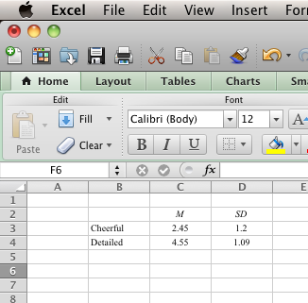

* + 1. Right click on cell > format cell > change to number > Two decimal places

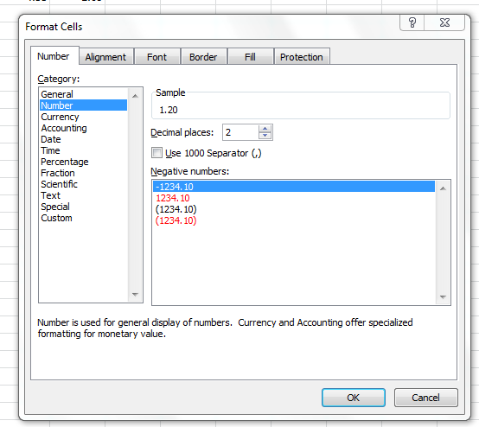

Table 1.

*Table Title Goes Here*.

|  |  |  |
| --- | --- | --- |
|  | *M* | *SD* |
| X variable | 10.50 | 2.50 |
| X variable | 11.45 | 1.85 |
| X variable | 9.09 | 3.02 |

*Note.* Some important information here.

1. Graphs (using SPSS chart builder)
   1. Some rules about graphs:
      1. Show the data and get the reader to think about the data (rather than having to think hard about what the graph is).
      2. Avoid distorting the data.
      3. Reveal the data! Encourage the reader to compare different pieces of information.
      4. Things to avoid:
         1. 3D charts
         2. Patterns
         3. Cylinders
         4. Bad axis labels
         5. Overlays
2. Chart Builder
   1. Graphs > Chart builder

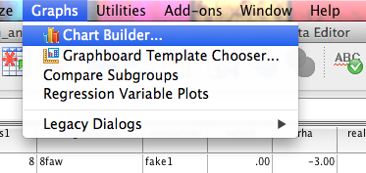

* 1. Chart builder window
     1. Variables on the left – the little icons denote what type of variable you’ve named it in variable view under measure.
        1. Three circles are nominal
        2. Little bar graph are ordinal
        3. Ruler icons are scale variables (interval/ratio)
     2. Chart preview
        1. Shows you an example of the chart you are creating.
        2. NOTE: It is NOT a real preview of the graph … it’s an idea of the graph, doesn’t actually graph your data.
        3. On the top left, variable names are listed with a symbol to the left of the name indicating the type of variable (nominal, ordinal, or scale).
        4. To change the type of variable you can right click on the variable name and change it to the desired variable type (nominal, ordinal, or scale)
     3. On the bottom, types of graphs you can choose from
     4. On the right, the subtypes of the graphs of the options on the left.
  2. You can double click or drag/drop the picture to get started on any graph.

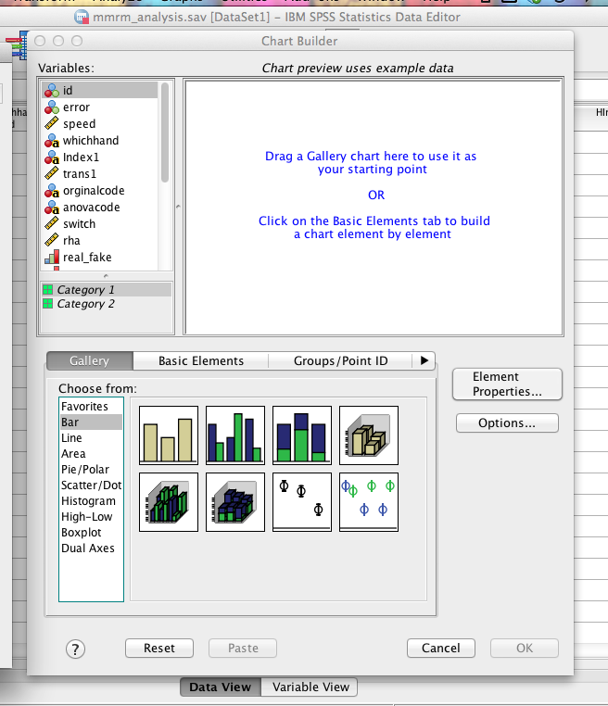

* 1. Bar graphs (used for data with groups)
     1. X axis will be a categorical variable.
     2. Y axis will be a continuous (scale) variable.
     3. If you do a clustered bar graph, you will get a “set color” option in the top right 🡪 that is for another categorical variable (i.e. 2 independent variables like ANOVA).

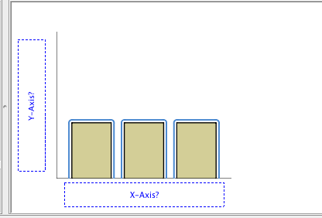

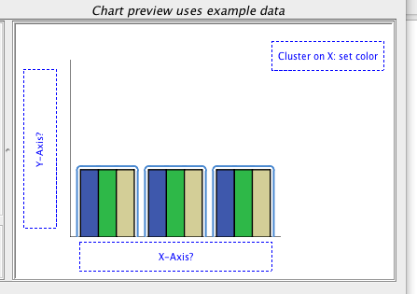

* + 1. In the element properties window
       1. Display error bars
       2. Clicking on each variable will give you options to do the proper labels (if you haven’t used the labels column in variable view).
       3. You can also change the minimum / maximum y-axis labels.
       4. You want to use y-axes that match the data 🡪 the range of the data, the scale of the data

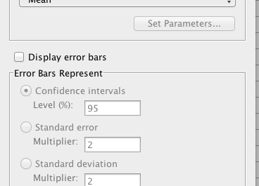

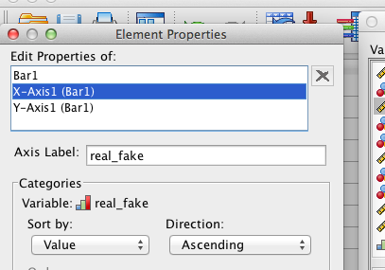

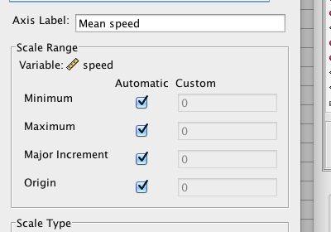

* + 1. Changing graph elements in the output window
       1. You can double click on the graphs to get the editor window.
       2. Then you can double click on the text, right click on the axes, etc. to change them.

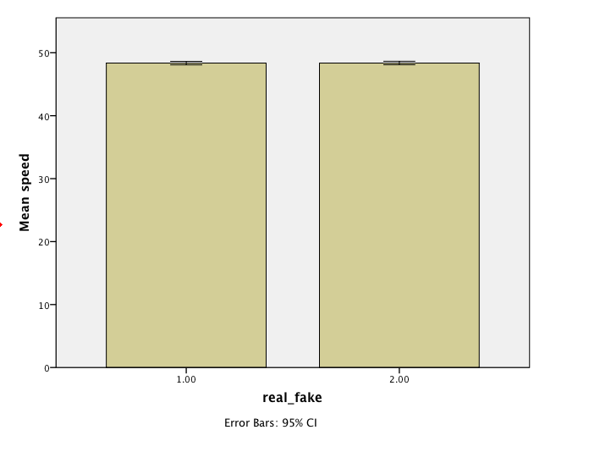

Bad graph with bad labels, no value labels, etc.

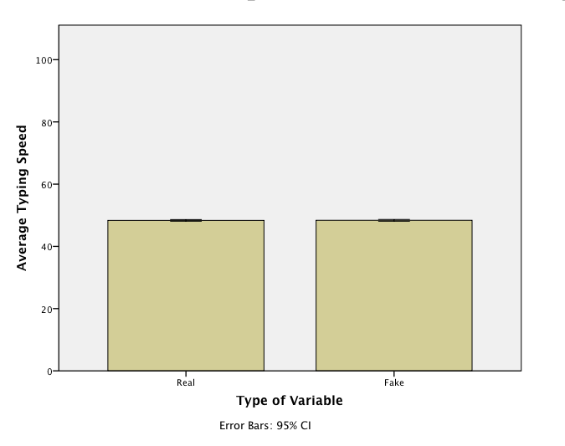

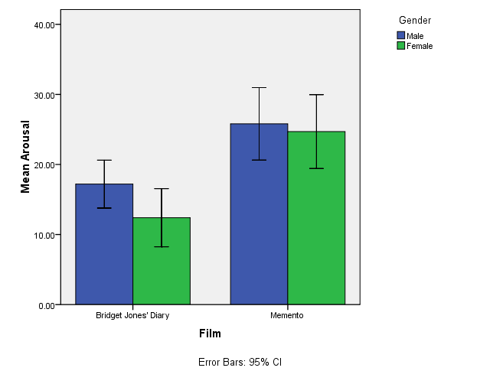

Better graph with x and y axes labels, value labels, etc.

* 1. Line graphs – used for data that’s continuous on the bottom (usually time variables)
     1. X axis should be continuous
     2. Y axis should be continuous
     3. You can do multiple variable graphs, set color should be a categorical variable (so you get separate lines for each group).

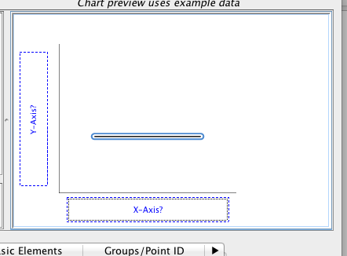

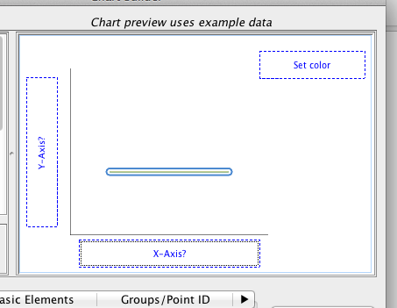

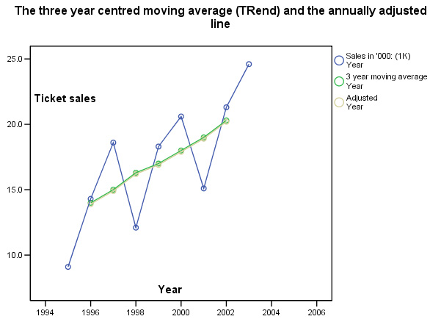

* 1. Scatterplots – used for two continuous variables
     1. X axis should be continuous
     2. Y axis should be continuous
     3. You can do multiple variable graphs, set color should be a categorical variable (so you would get different color dots for each group)

